**DIGITAL CIRCUITS LABORATORY**

**Experiment-8**

**3-bit Adder/Subtractor, ALU, Priority Encoder using VHDL and CPLD Board**

Tanish H Talapaneni

200020050

**Aim:**To implement the 3-bit Adder, priority encoder and the given ALU by writing the code in structural model using VHDL and implementing it on the CPLD Board

**Summary:** Implementation of the 3-bit Adder, priority encoder and the given ALU (by using the previously coded architecture of a full adder) on CPLD board by wiring up the circuit and executing the Structurally-modeled VHDL code

**Components used:**CPLD Board, PC

**Procedure:**

* Configure the Quartus Software and open a new project
* Writing the code for 3-bit Adder and VHDL in VHDL
* Compiling the code and correcting all errors
* Viewing the RTL schematic of the written VHDL Code
* Creating .svf file and planning the pins for outputs and inputs, in order to execute on the CPLD Board
* Running the code on the CPLD Board by executing it via the Terminal Window on the PC

**3-bit Adder/Subtractor**

**Truth Table for Adder:**

| **A** | **B** | **C** | **Carry** | **Sum** |
| --- | --- | --- | --- | --- |
| **0** | **0** | **0** | **0** | **0** |
| **0** | **0** | **1** | **0** | **1** |
| **0** | **1** | **0** | **0** | **1** |
| **1** | **0** | **0** | **0** | **1** |
| **0** | **1** | **1** | **1** | **0** |
| **1** | **0** | **1** | **1** | **0** |
| **1** | **1** | **0** | **1** | **0** |
| **1** | **1** | **1** | **1** | **1** |

**Truth Table for Subtractor:**

| **A** | **B** | **C** | **Difference** | **Borrow** |
| --- | --- | --- | --- | --- |
| **0** | **0** | **0** | **0** | **0** |
| **0** | **0** | **1** | **1** | **1** |
| **0** | **1** | **0** | **1** | **1** |
| **1** | **0** | **0** | **0** | **1** |
| **0** | **1** | **1** | **1** | **0** |
| **1** | **0** | **1** | **0** | **0** |
| **1** | **1** | **0** | **0** | **0** |
| **1** | **1** | **1** | **1** | **1** |

**VHDL code for 3-bit Adder/Subtractor (Dataflow)**

library ieee;

use ieee.std_logic_1164.all;

entity fulladder is

port( i1, i2, i3: in std_logic;

o1, o2: out std_logic);

end fulladder;

architecture FA of fulladder is

Begin

o1 <= i1 xor i2 xor i3;

o2 <= (i1 and i2) or ((i1 xor i2) and i3);

end FA;

library ieee;

use ieee.std_logic_1164.all;

entity adder3 is

port(a: in std_logic_vector (2 downto 0);b: in std_logic_vector (2 downto 0);

m: in std_logic;

sum: out std_logic_vector (2 downto 0);

cout: out std_logic);

end adder3;

architecture struct of adder3 is

component fulladder is

port( i1, i2, i3: in std_logic;

o1, o2: out std_logic);

end component;

signal c1,c2: std_logic;

signal z: std_logic_vector (2 downto 0);

begin

z(0) <= b(0) xor m;

z(1) <= b(1) xor m;

z(2) <= b(2) xor m;

u1: fulladder port map ( a(0), z(0), m, sum(0), c1 );

u2: fulladder port map ( a(1), z(1), c1, sum(1), c2 );

u3: fulladder port map ( a(2), z(2), c2, sum(2), cout );

end struct;

**RTL netlist for the 3-bit Adder/Subtractor**

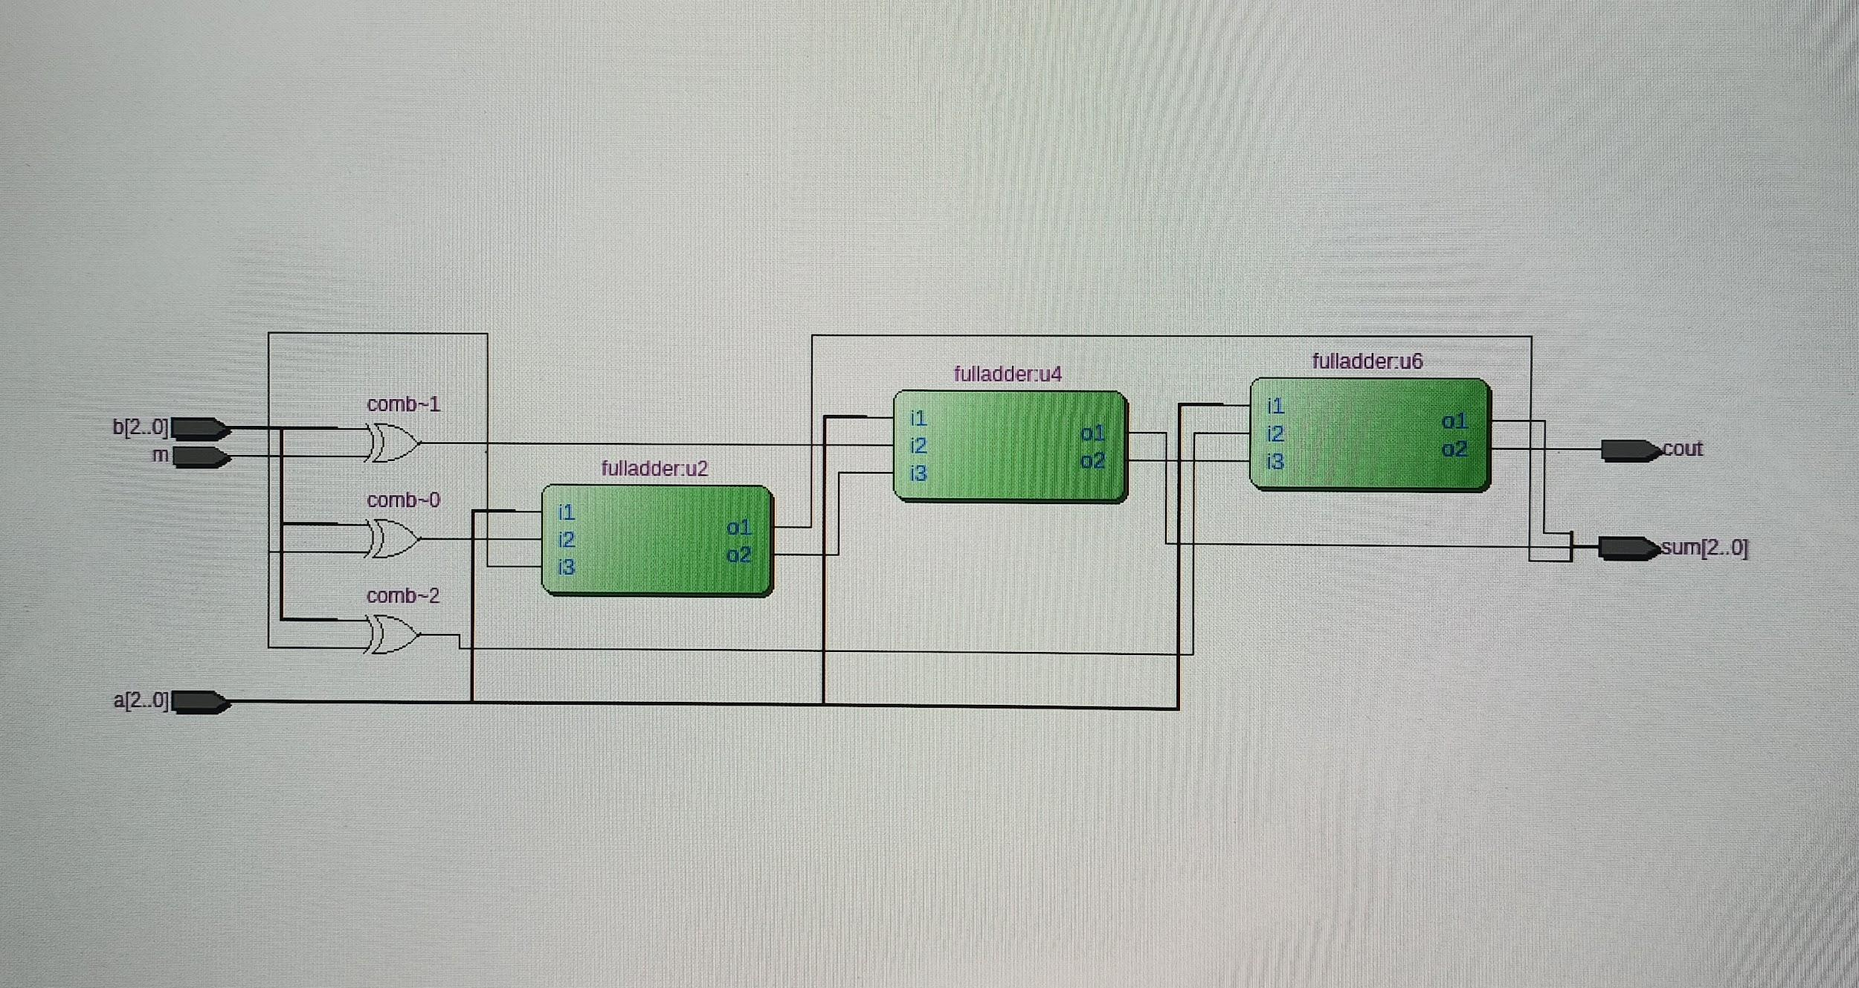

**VHDL Code for the ALU**

library ieee;

use ieee.std_logic_1164.all;

entity ALU is

port( A, B: in std_logic_vector(2 downto 0); ALU_Sel: in std_logic_vector(1 downto 0);

ALU_Out : out std_logic_vector(3 downto 0);

end ALU;

architecture behavior of ALU is

signal c2: std_logic; signal c3: std_logic;

Begin

c1 : process(A, B, ALU_Sel)

begin

case ALU_Sel is:

when "00"=>

ALU_Out(0) <= A(C) xor B(0);

c2 <= A(0) and B (0);

ALU_Out (1) <= (A(1) xor B(1)) xor c2;

c3 <= ((A(1) and B(1)) or ((A(1) and c2) or (B(1) and c2)));

ALU_Out(2) <= (A(2) xor B (2)) xor c3;

ALU_Out(3) <= ((A(2) and B(2)) or

((A(2) and c3) or (B(2) and c3)));

– for second case

when "01"=>

ALU_Out(0) <= A(C) xor (not B(0));

c2 <= A(0) and (not B(0));

ALU_Out (1) <= (A(1) xor (not B(1))) xor c2;

c3 <= ((A(1) and (not B(1))) or ((A(1) and c2)

or ((not B(1)) and c2)));

ALU_Out(2) <= (A(2) xor (not B(2))) xor c3;

ALU_Out(3) <= ((A(2) and (not B(2))) or ((A(2)

and c3) or ((not B(2)) and c3)));

– for third case

when "10"=>

ALU_Out(3) <= '0';

ALU_Out(2) <= A(2) and B(2);

ALU_Out(1) <= A(1) and B(1);

ALU_Out(0) <= A(0) and B(0);

– for fourth case

when "11"=>

ALU_Out(3) <= '0';

ALU_Out(2) <= A(2) xor B(2);

ALU_Out(1) <= A(1) xor B(1);

ALU_Out(0) <= A(0) xor B(0);

end case;

end process c1;

end behavior;

RTL view for the code of ALU:

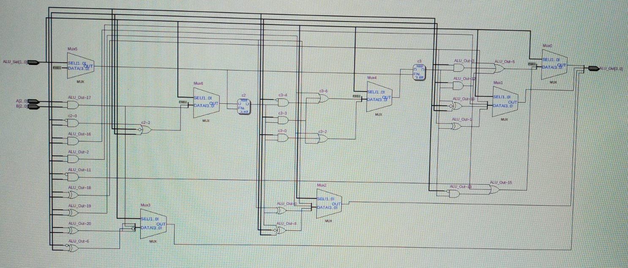

**VHDL code for 4:2 Priority Encoder**

library ieee;

use ieee.std_logic_1164.all;

entity p_enc is

port(encoder_in : in std_logic_vector(3 downto 0);bin_out : out std_logic_vector(1 downto 0);

enable : in std_logic);

end p_enc;

architecture behavior of p_enc is

begin

c1 : process(enable, encoder_in)

begin

if enable = '0' then

bin_out(0) <= '0';bin_out(1) <= '0';

else

if encoder_in(0) = '1' then

bin_out(0) <= '0';bin_out(1) <= '0';

elsif encoder_in(1) = '1' then

bin_out(0) <= '0';bin_out(1) <= '1';

elsif encoder_in(2) = '1' then

bin_out(0) <= '1';bin_out(1) <= '0';

elsif encoder_in(3) = '1' then

bin_out(0) <= '1';bin_out(1) <= '1';

end if;

end if;

end process c1;

end behavior;

**RTL view for code of 4:2 Priority Encoder**

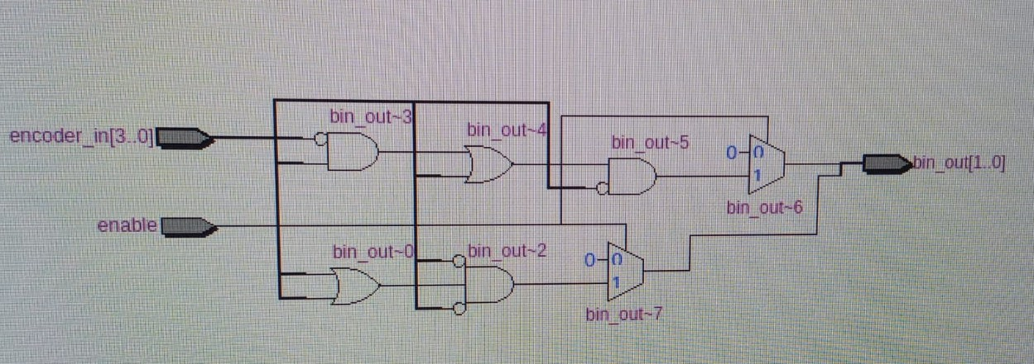

**Hardware:**

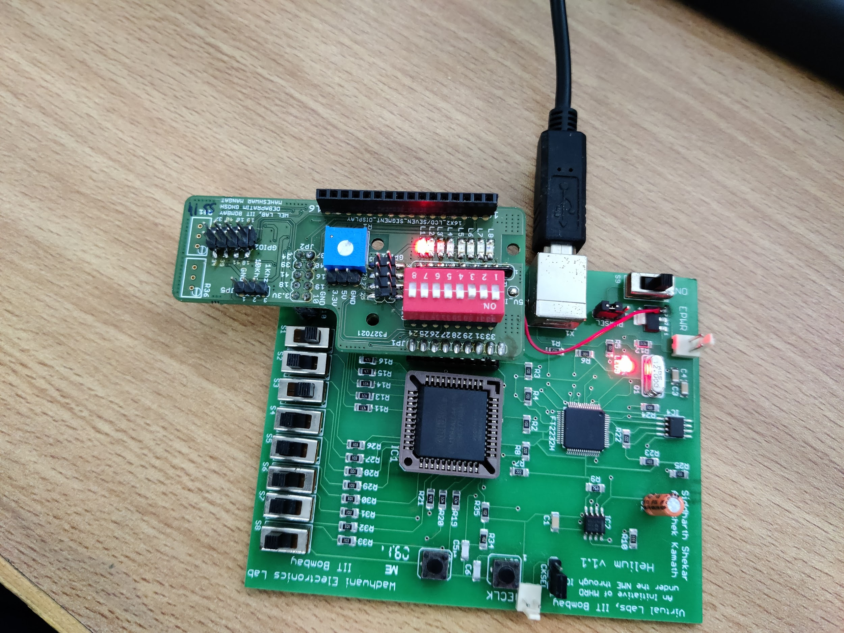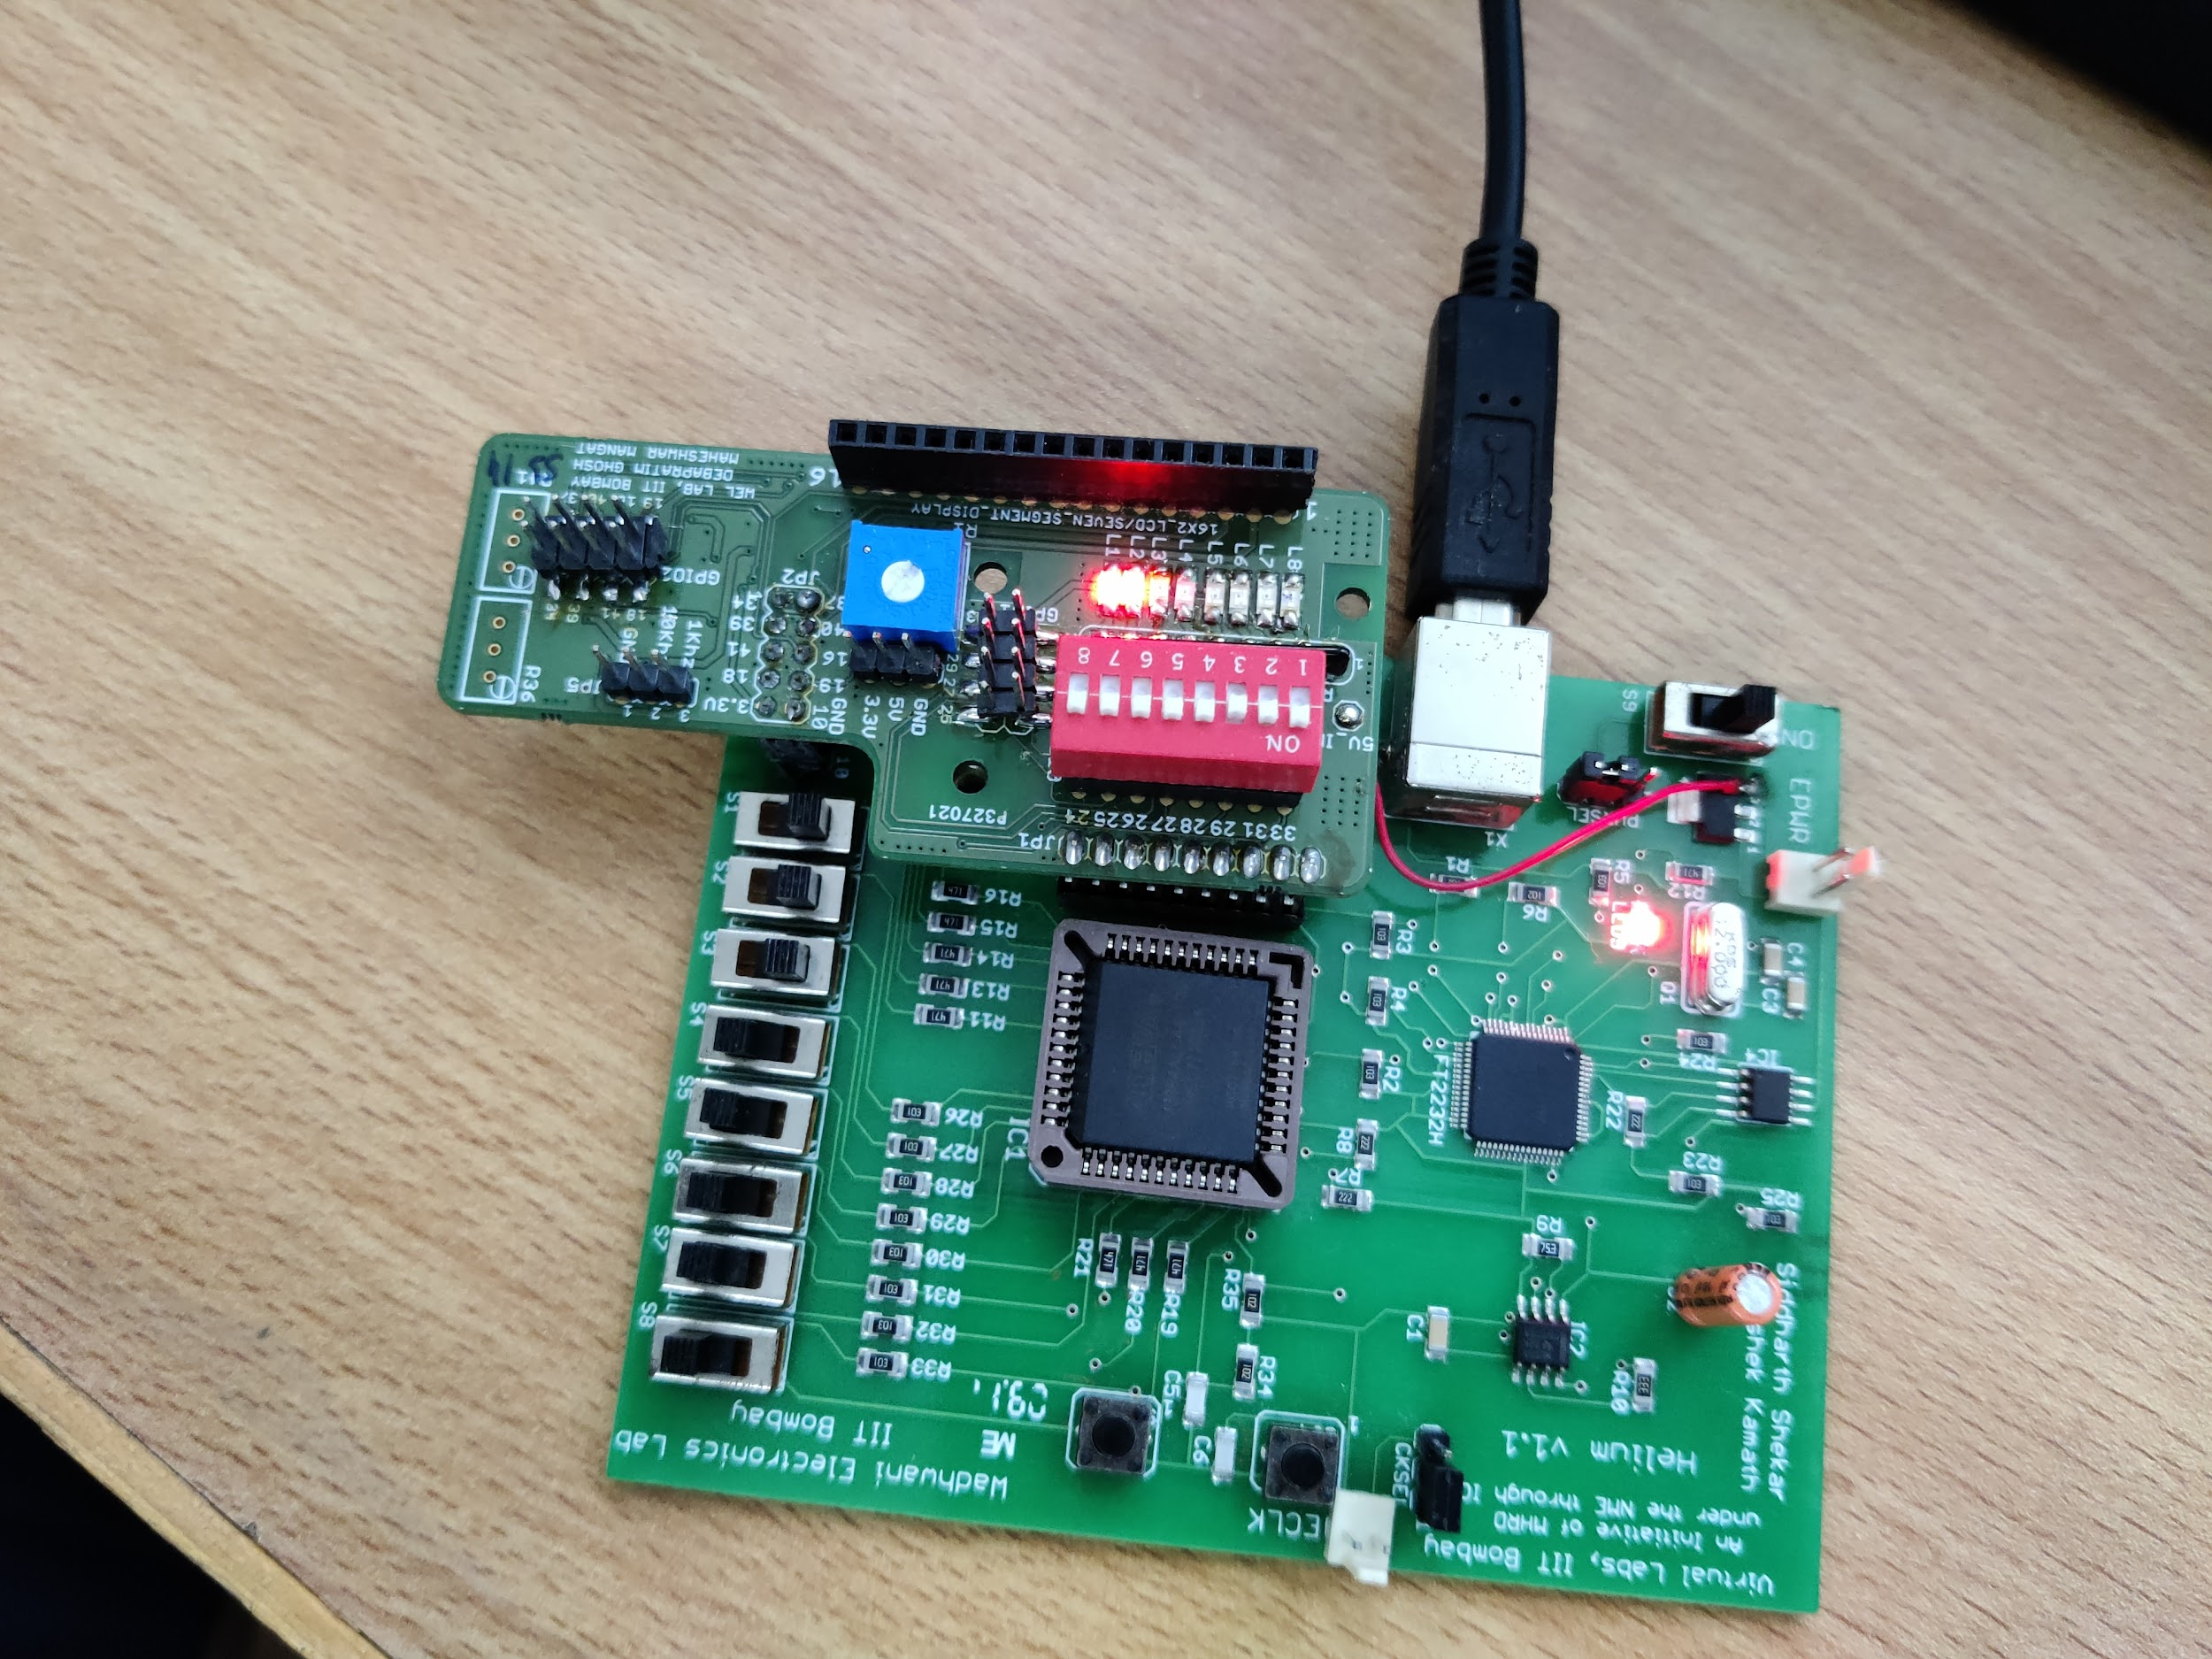

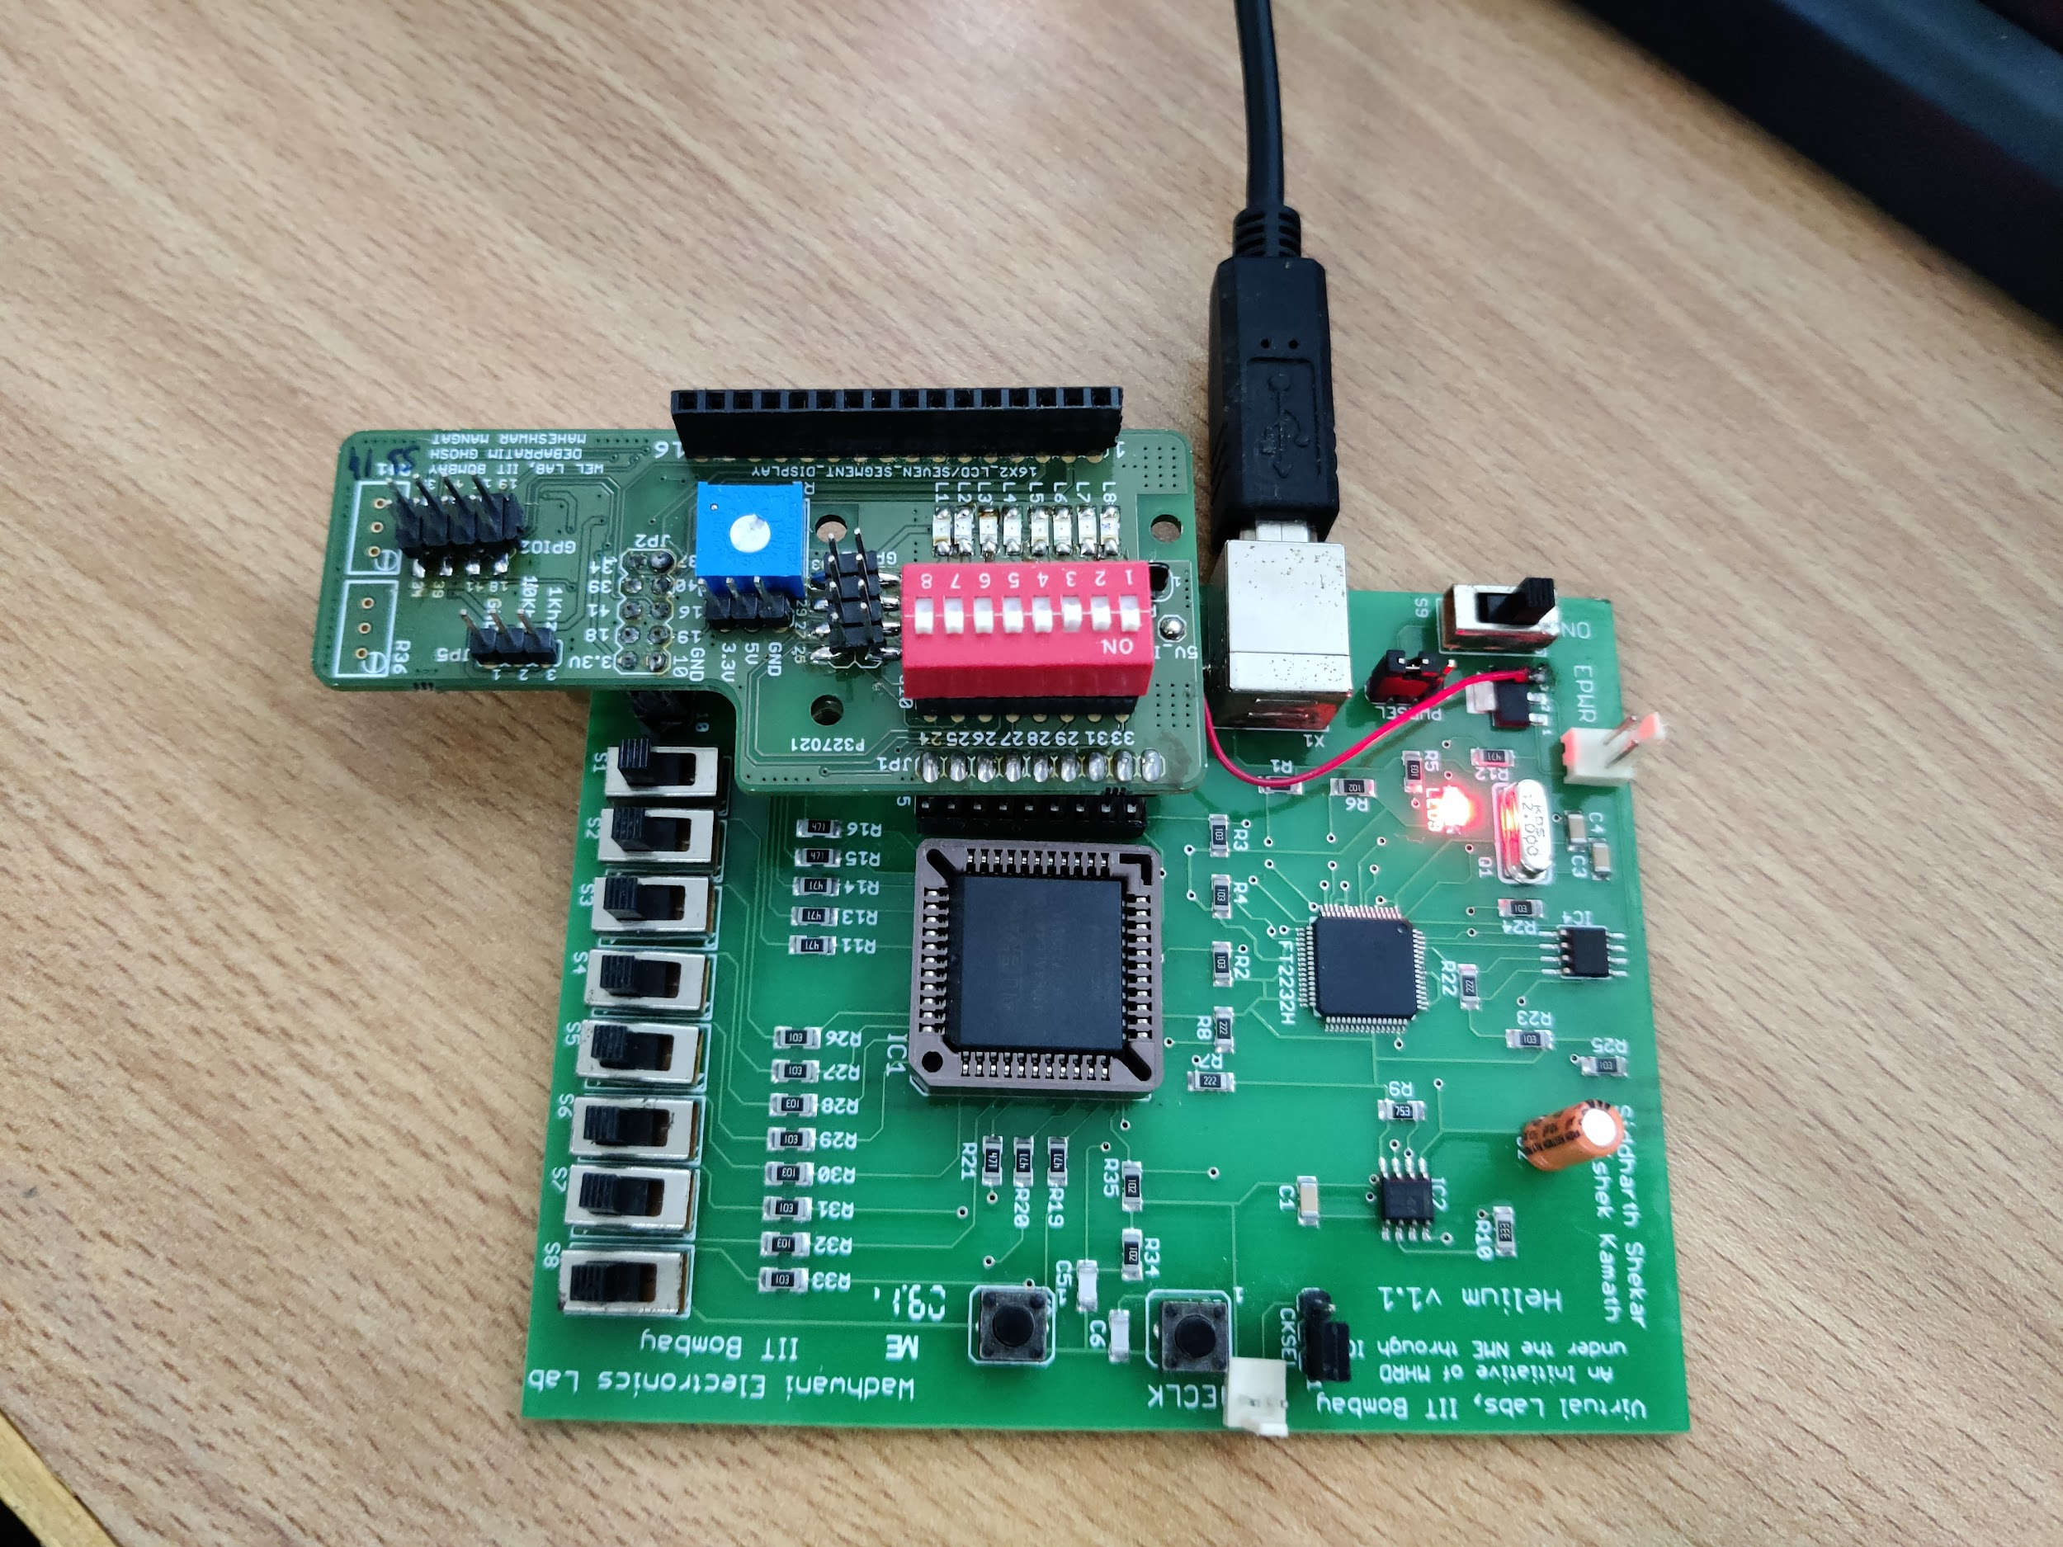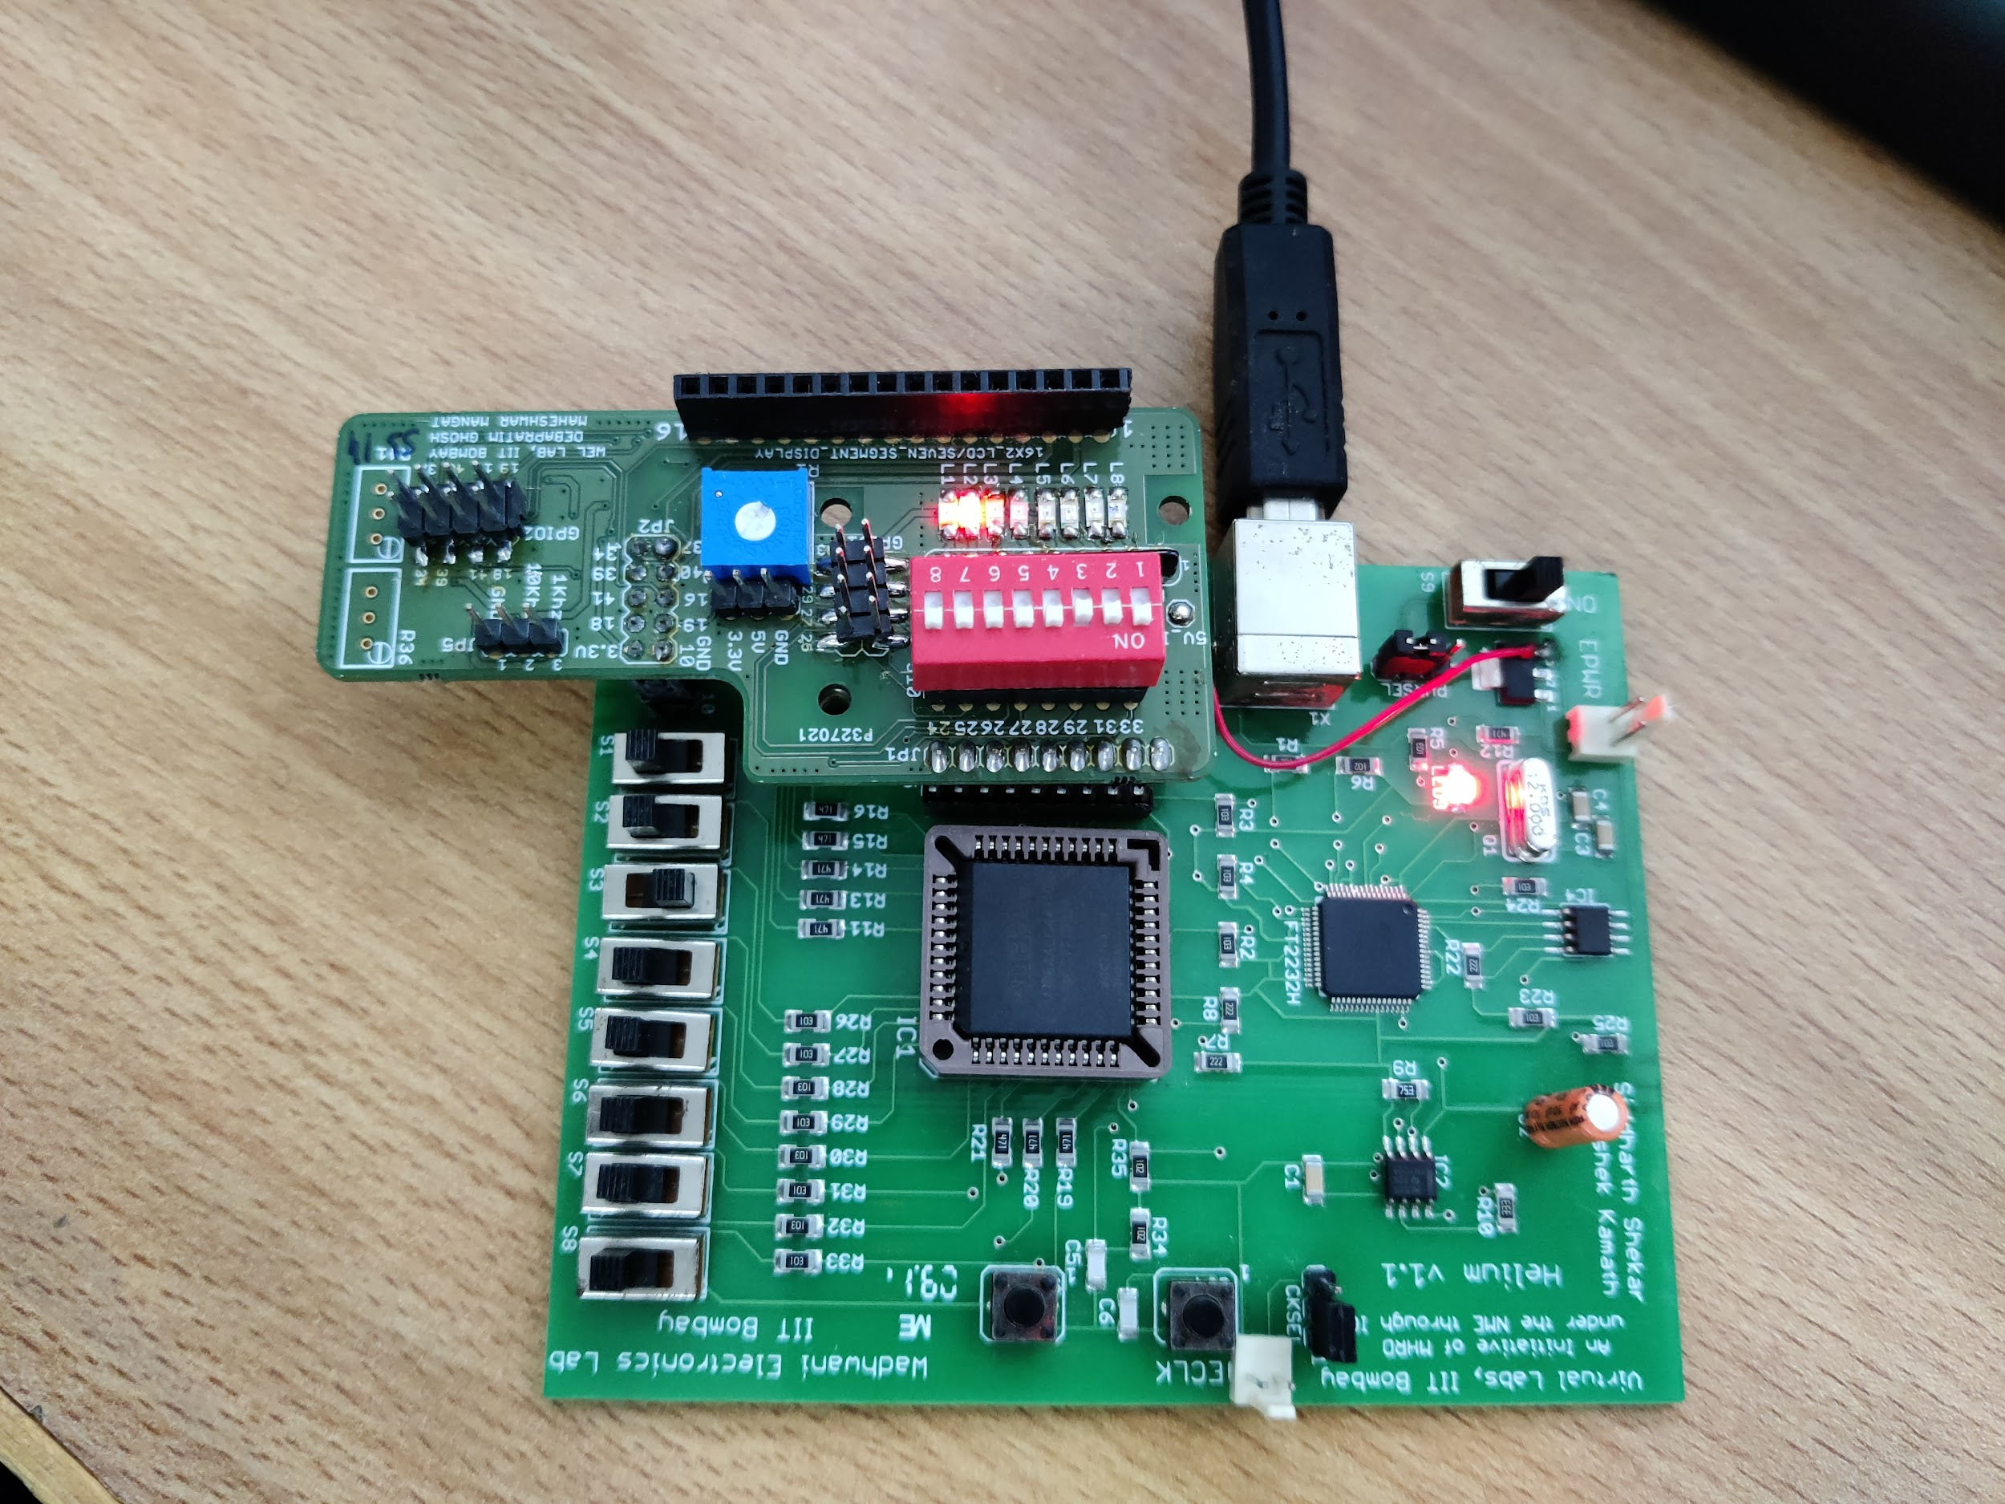

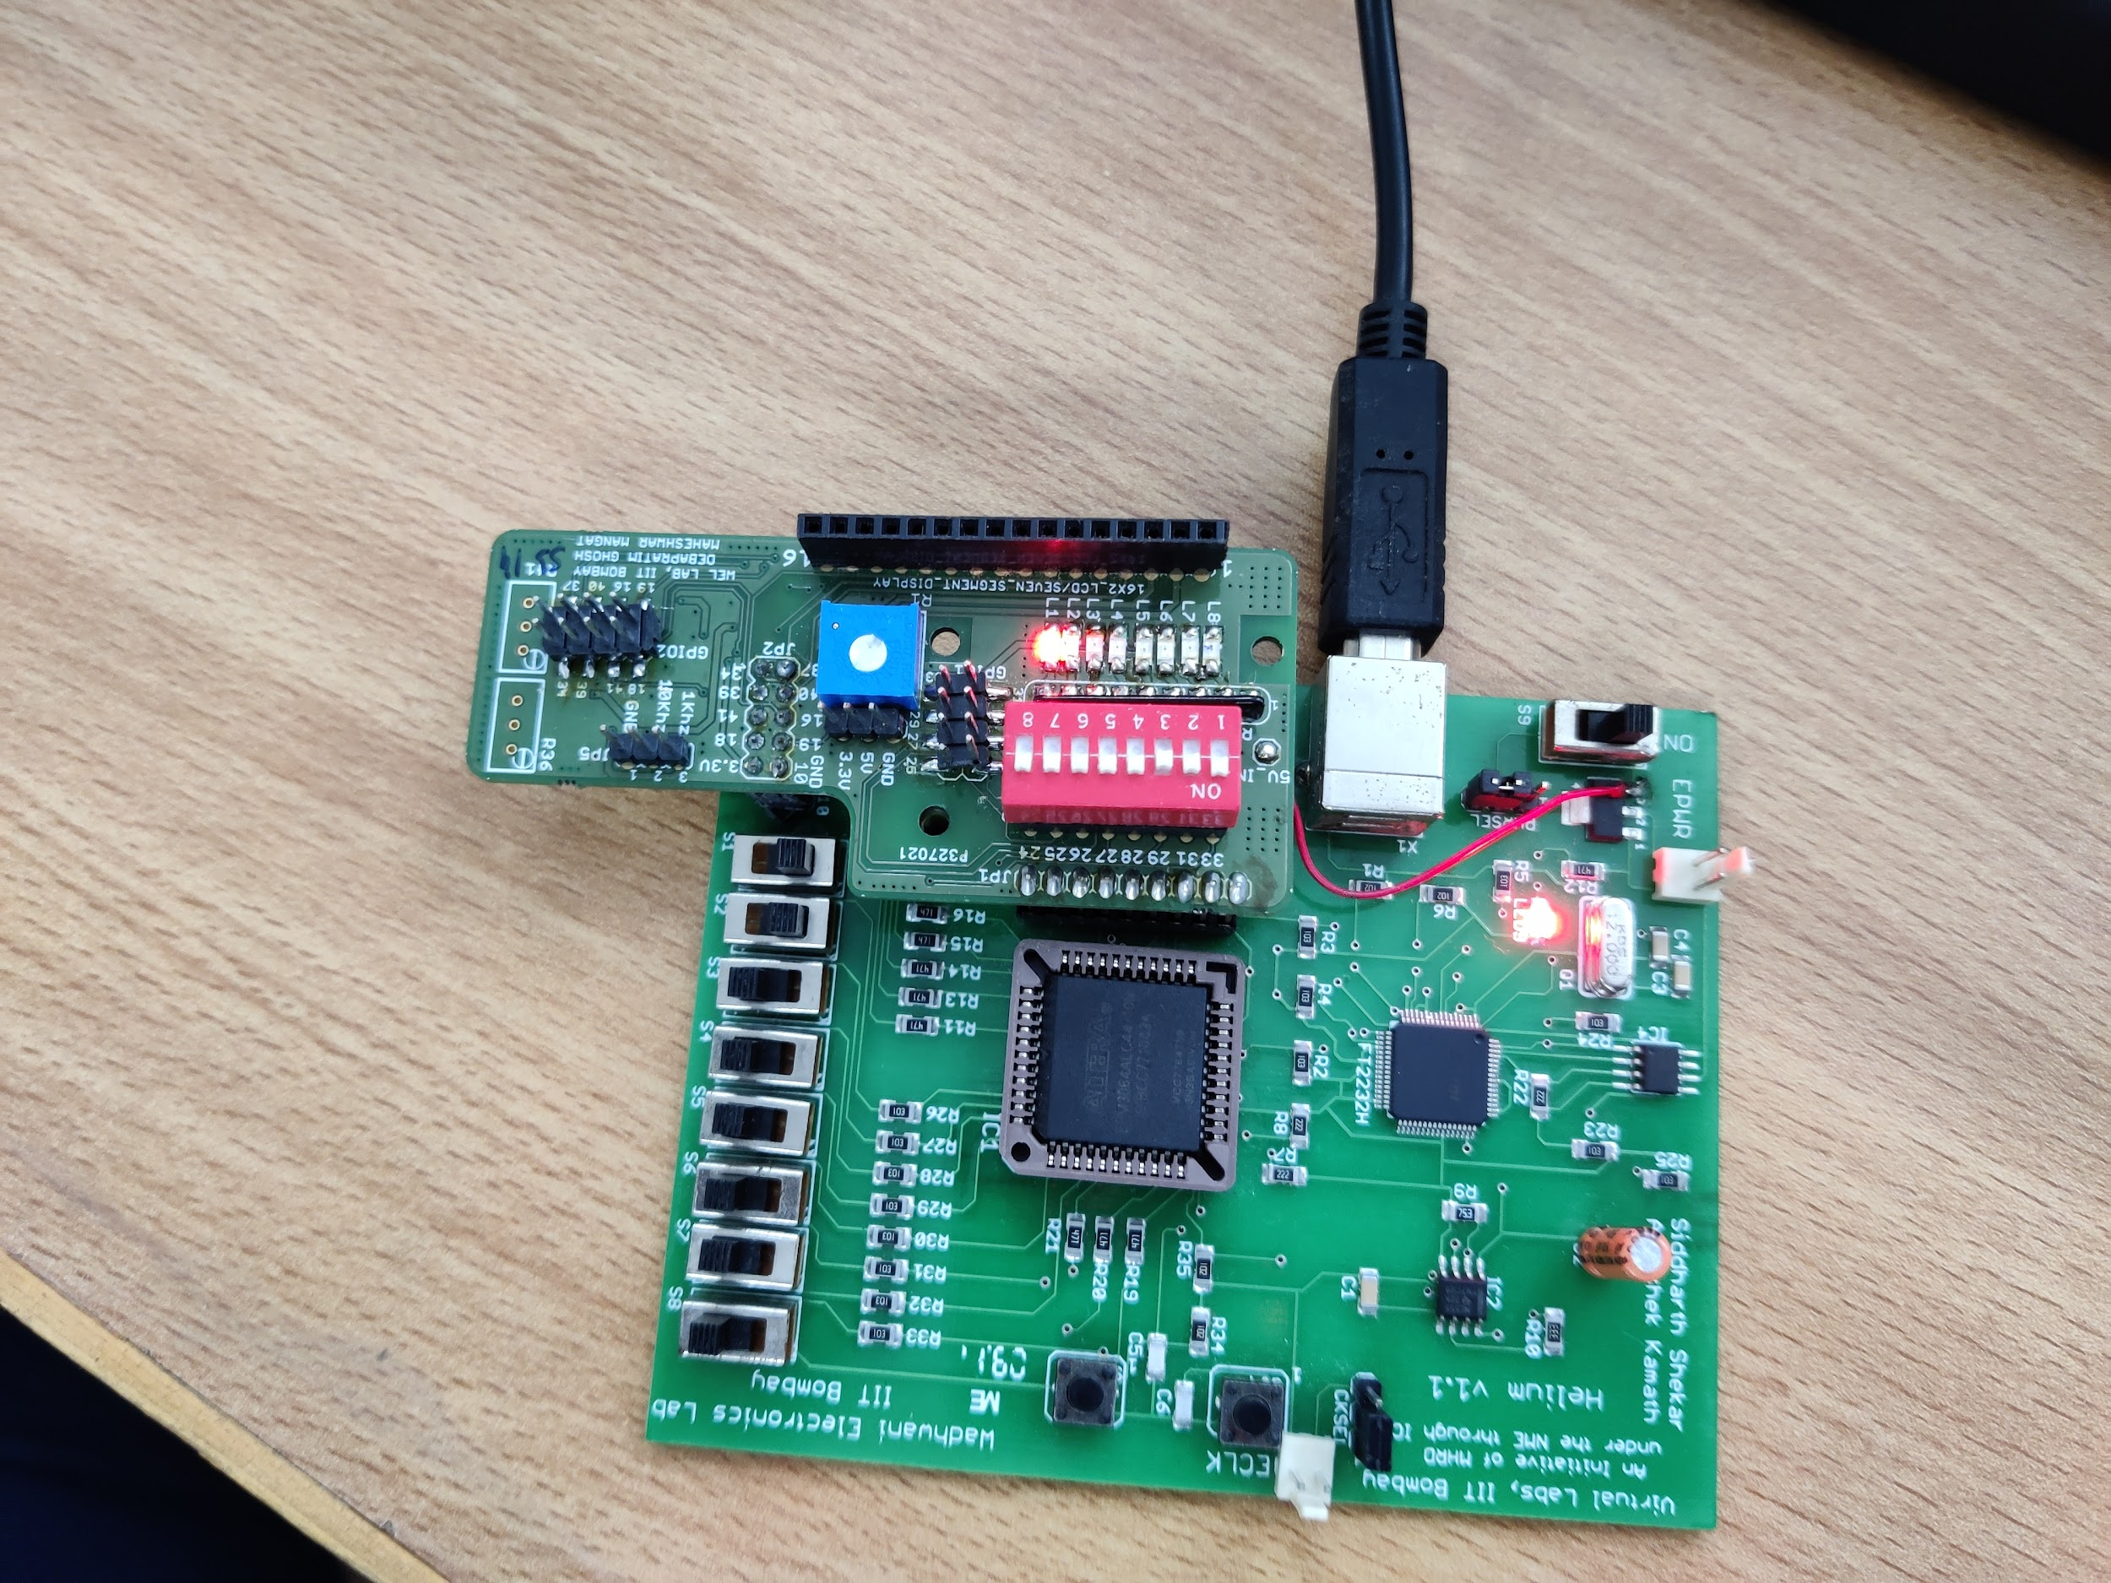

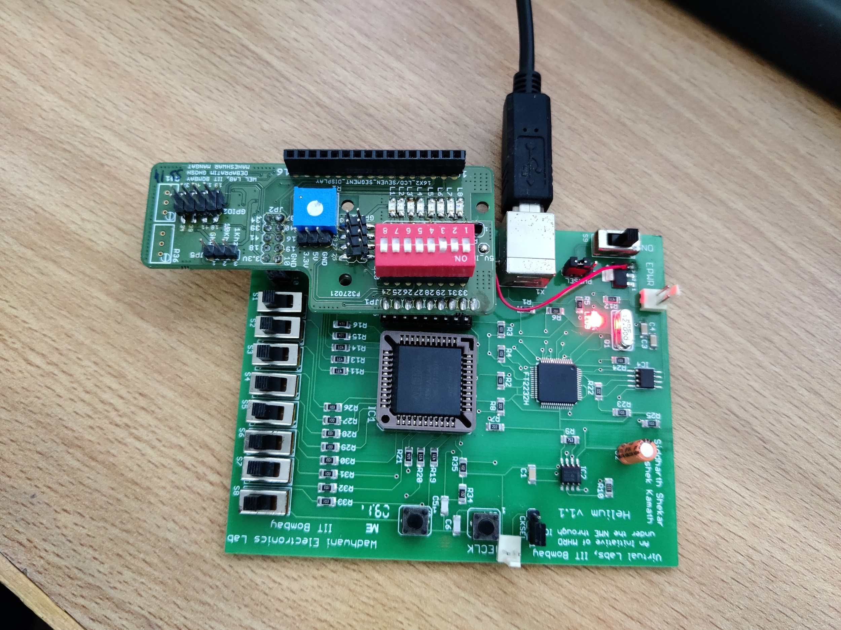

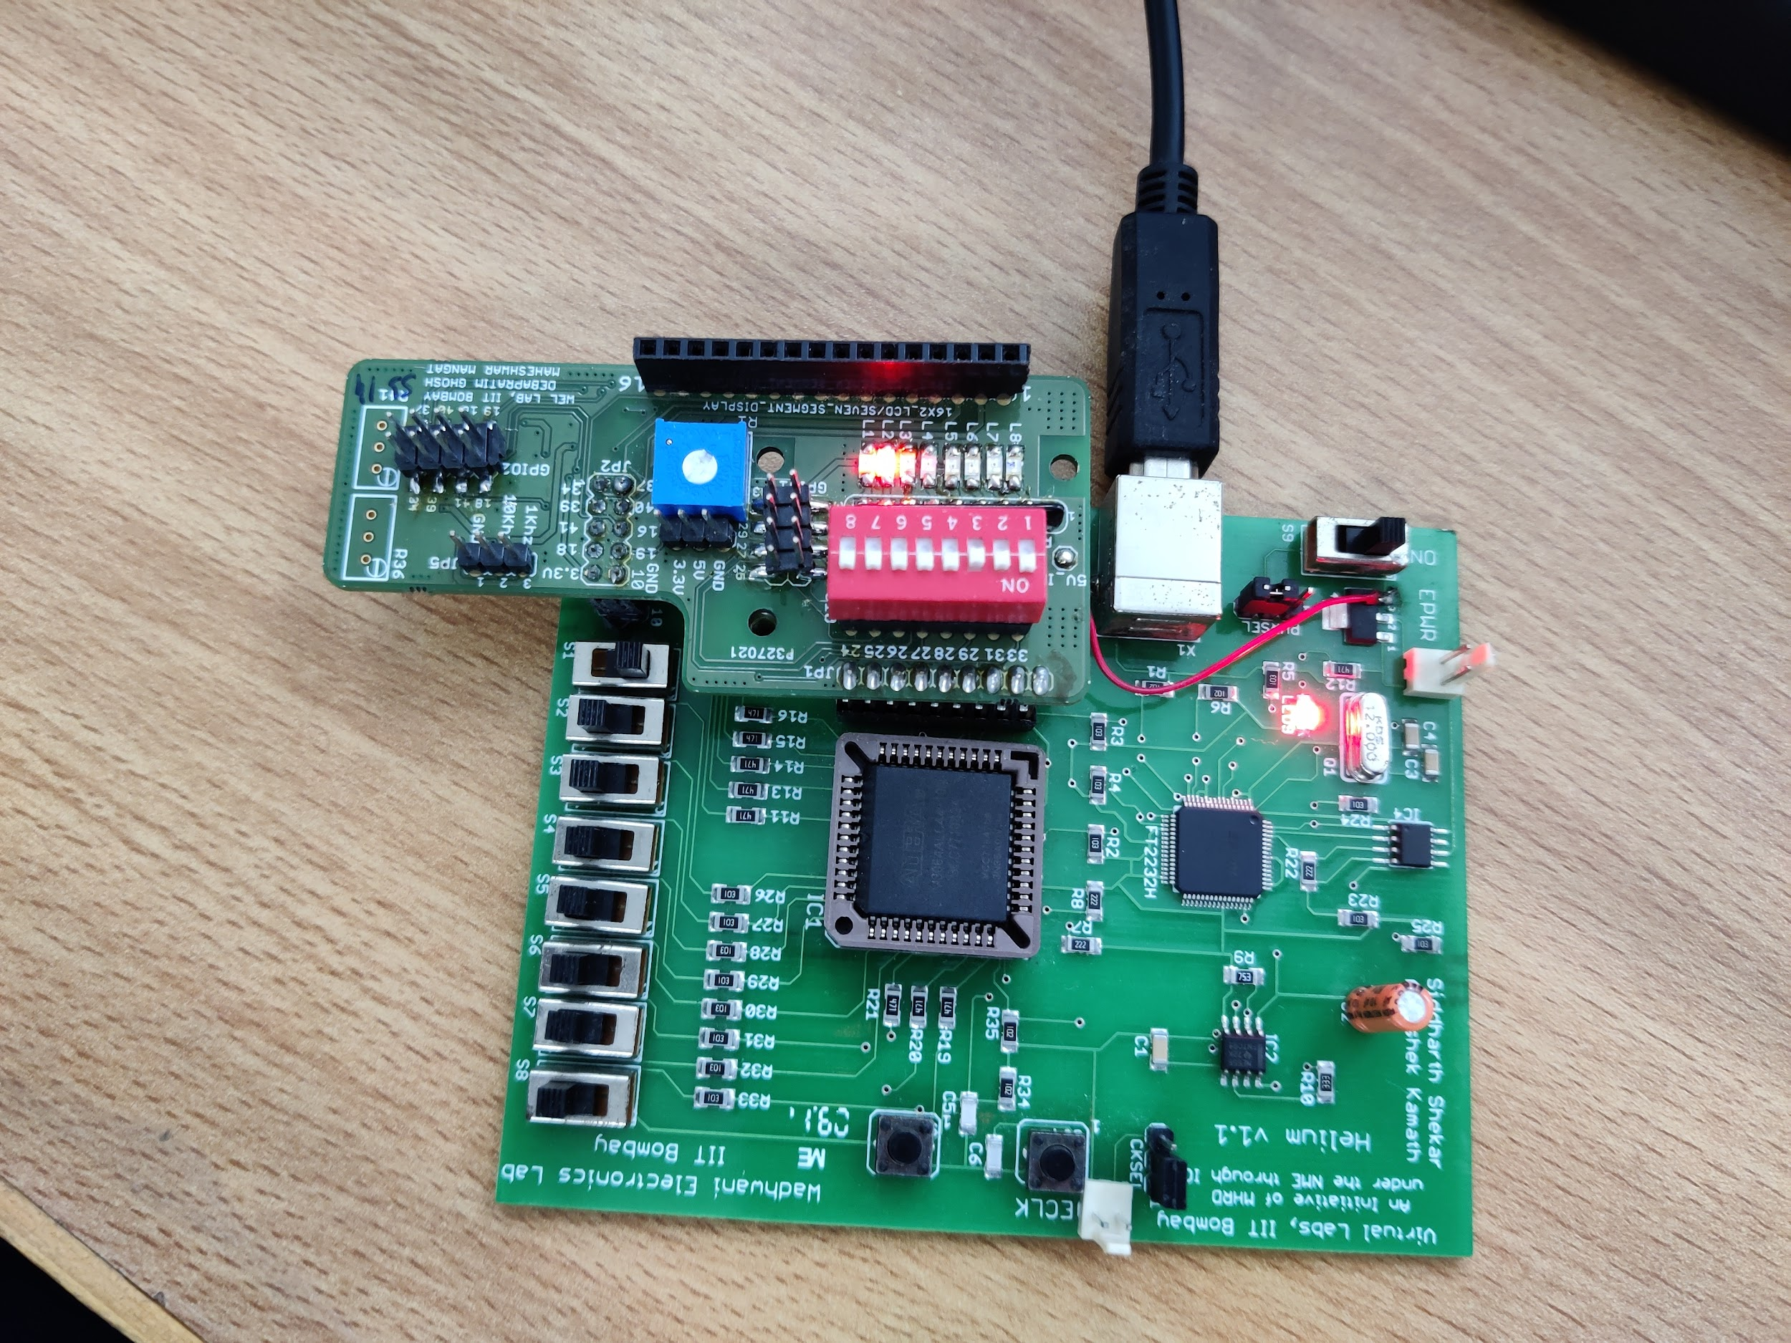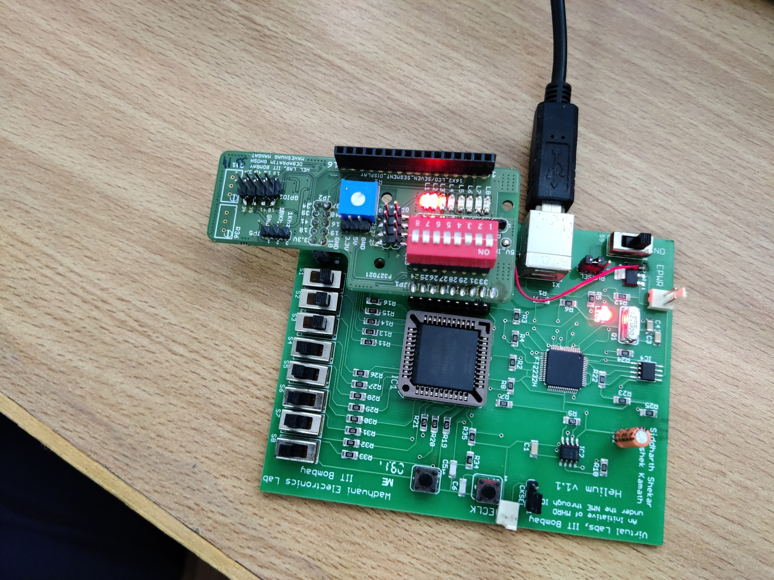

**Results and Discussions:** We were able to program further in VHDL and used the CPLD Board to execute the working of the 3-bit adder. Initially, it was tricky to configure the software, as few more components were involved compared to last time, but we were able to structure it well finally and observed the desired output on the CPLD board. Then, we coded the logic of the given Arithmetic Logic unit, which involved two other external inputs, which acted as switches, that decided which operation to perform on the inputs. After that, we coded for the 4:2 Priority encoder and executed it on the CPLD Board. It was a great experience working with VHDL and CPLD, and to observe the outputs of the 3-bit adder and the ALU

**Conclusion:**

Execution of 3-bit Adder Logic and the ALU on the CPLD Board using VHDL Programming Language. The 3-bit Adder has another input m, which decides whether to add or subtract the given numbers. In order to subtract, 2’s complement of the second number is to be executed, which is done by XOR operation with m=1, and then adding m=1 as carry to the first full adder. m=0 for addition. The ALU takes in two inputs, and can thus perform a maximum of four operations, according to the design of the ALU. The 4:2 Priority Encoder takes in 4 inputs and gives out 2 outputs, and also uses an active high enable pin. The output observed is the same as the theoretical results obtained for the 3-bit Adder/Subtractor, the ALU, and the Priority Encoder..